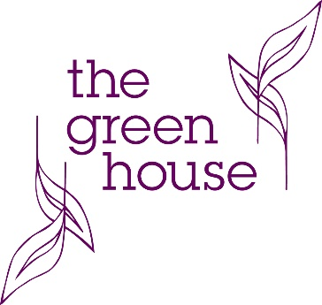

Get the Wedding Glow: Inside and Out
You’ve booked your venue, you’ve got the dress now it’s time to concentrate on you getting that wedding day glow inside and out. Round up your bridal party and join us for an afternoon tea with a difference. Barbara Cox, internationally renowned nutritionist, will advise on the best diet tips to get you glowing for the big day. Tess from WiDEYE will talk about the best skincare routine and how to disguise those unwanted blemishes as well as providing tools to help you sleep well on the run up to your wedding. Don’t forget your goodie bag packed with samples and discounts too.

Date: 26th April 2020, starts at 2:30pm -4:30pm
Arrival: Sparkling cocktail reception at 2:30pm followed by afternoon tea (please advise us in advance of any dietary requirements)
What to bring: There will be items to purchase on the day so please bring cash only as Barbara and Tess don’t have mobile card readers.
How to book: You can book online at arbor-restaurant.co.uk/book-a-table or call us on 01202498900 or email us on reservations@thegreenhousehotel.com

A little more about our speakers:
Barbara Cox will chat on how to “Get the Wedding Glow Inside”. Working from the 6-month mark before your wedding right up until the night before Barbara will advise on what foods to eat as well as relaxation routines.
Tess from WiDEYE will chat on how to “Get the Wedding Glow on the outside”. The tools to help you get a good night’s sleep, overcome stress skin and blemishes. WiDEYE is a company that follows our own eco values, where every product is thought about its impact on the environment before using it.

